**//write all in words in the end. Do not give the screenshot pictures as then troy will cut marks!!!**

1.Your explanation of all the evidence received from the Police, how and when it was received and how you handled continuity (chain of custody) of the digital evidence. (1 mark)

2. Your explanation of the item received from your colleague Troy, how and when it was received and how you handled continuity (chain of custody) of the item. (1 mark)

(ALL hashes LIST both obtained and also checked by self:)

. Disk image “ImaHacker.E01” – Downloaded from Canvas

Timeline of system events “timeline.csv” - Email (MD5: 9574ac771fdeeeb9a95d8dda5ed1749a)

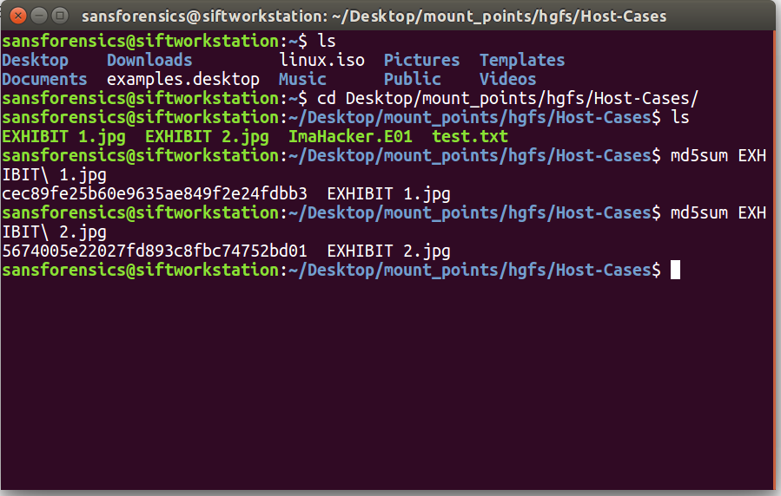



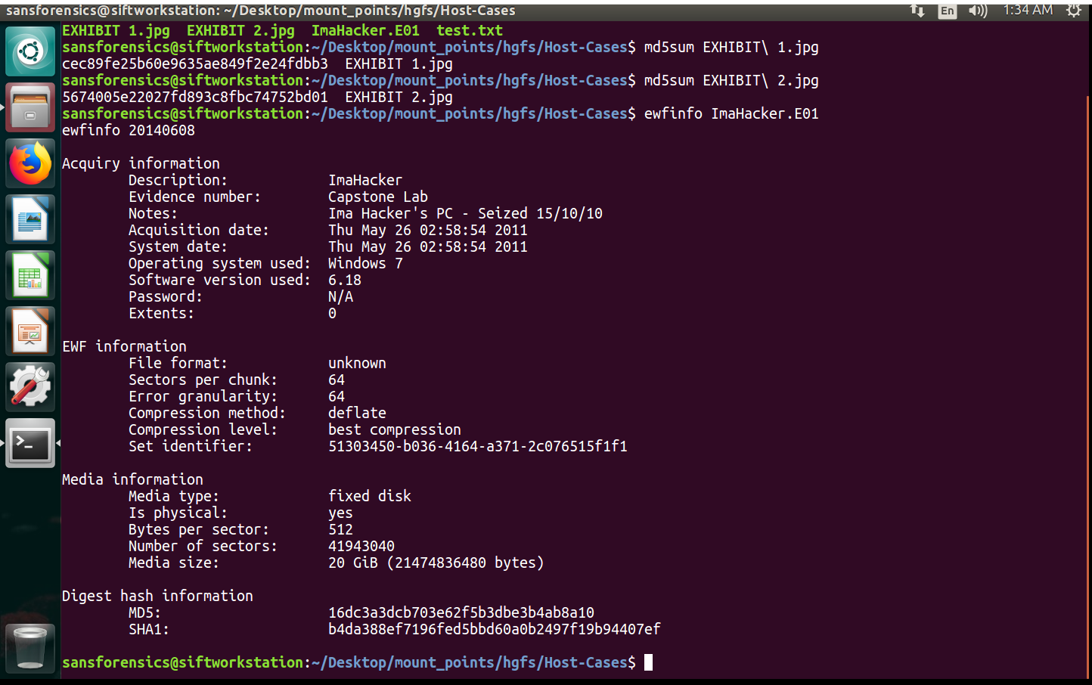

Also did ewfverify to ensure hash contained within was correct..

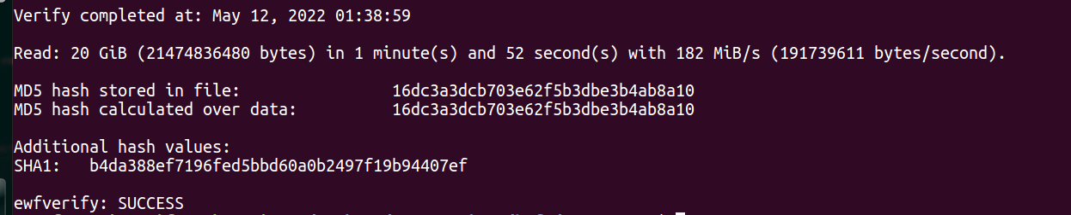

3. Details of the partition contained within the image, and determination of the seized devices time zone (2marks)

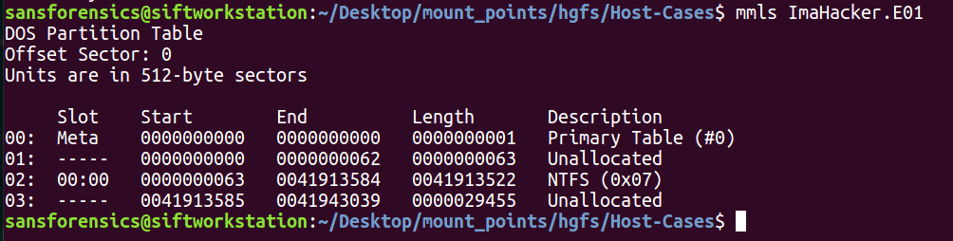

(make partition table format using those datas)

63*512= 32,256 (starting offset)

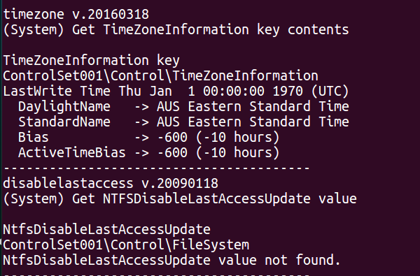

4. Evidence and explanation for the alleged "Hackable" attack (5 marks)

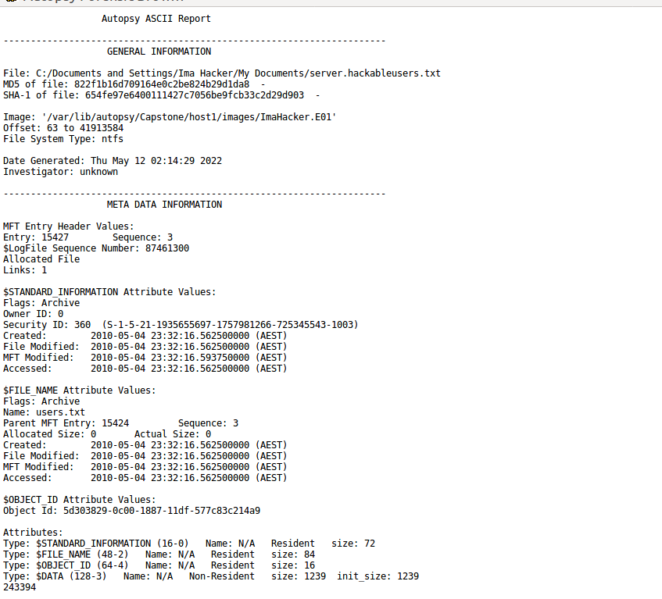

So he attacked and gained access to list of user names

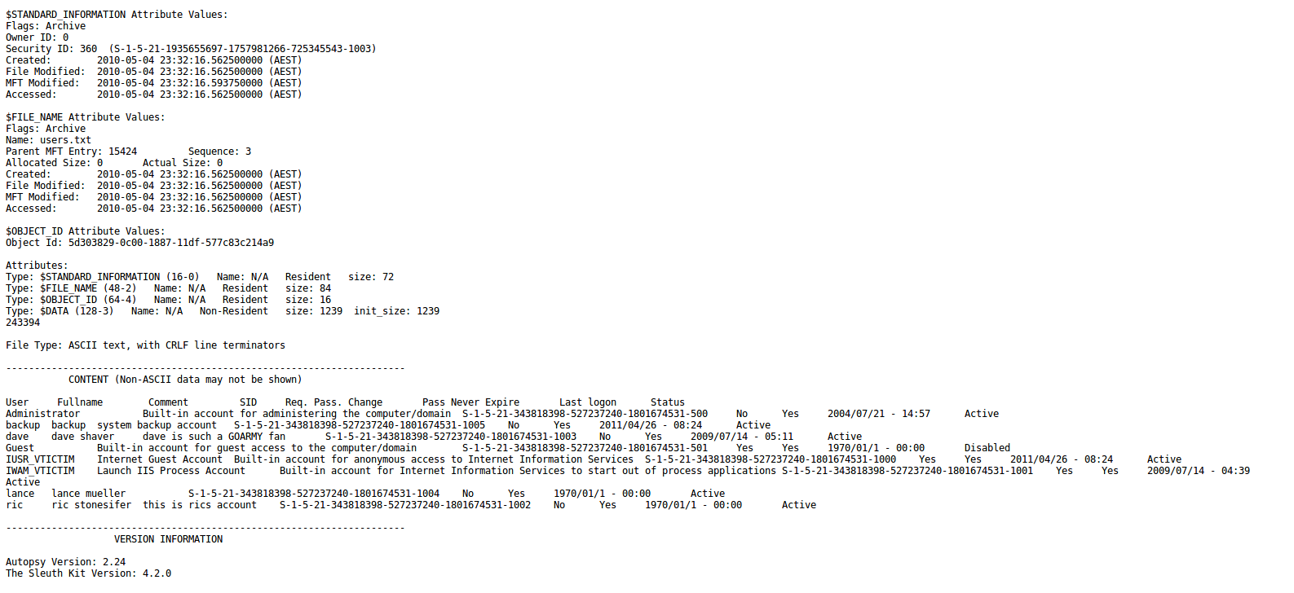

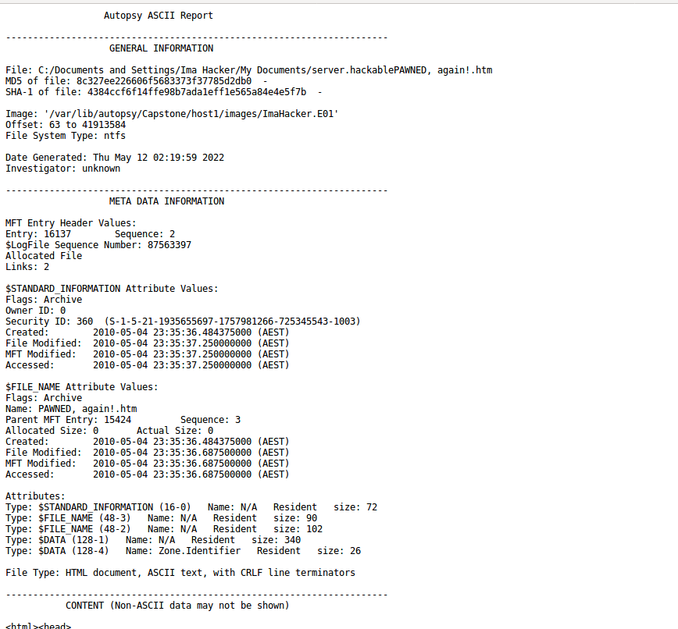

Also he did an nmap attack which

“This program scans the network that a computer is connected to and outputs a list of ports, device names, operating systems, and several other identifiers that help the user understand the details behind their connection status. Nmap can be used by hackers to gain access to uncontrolled ports on a system”

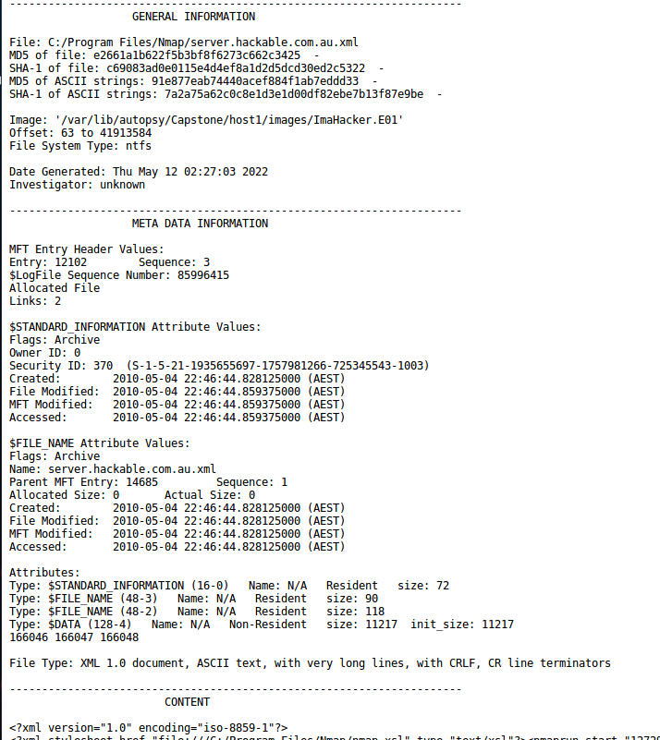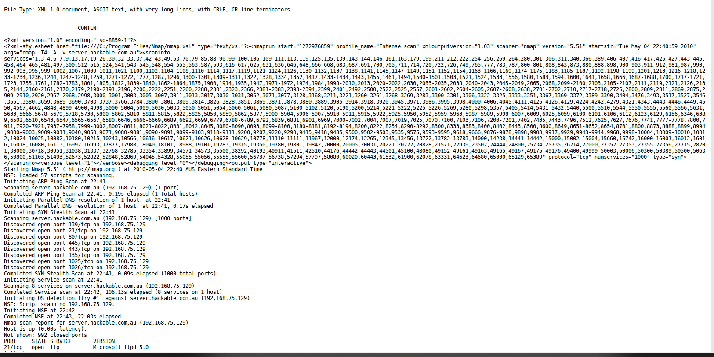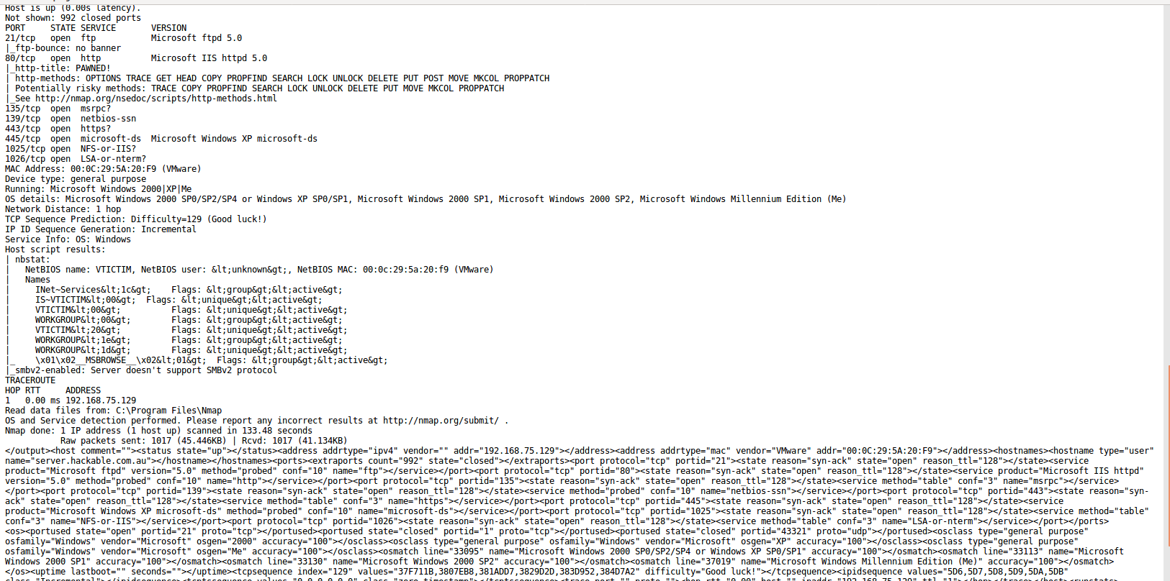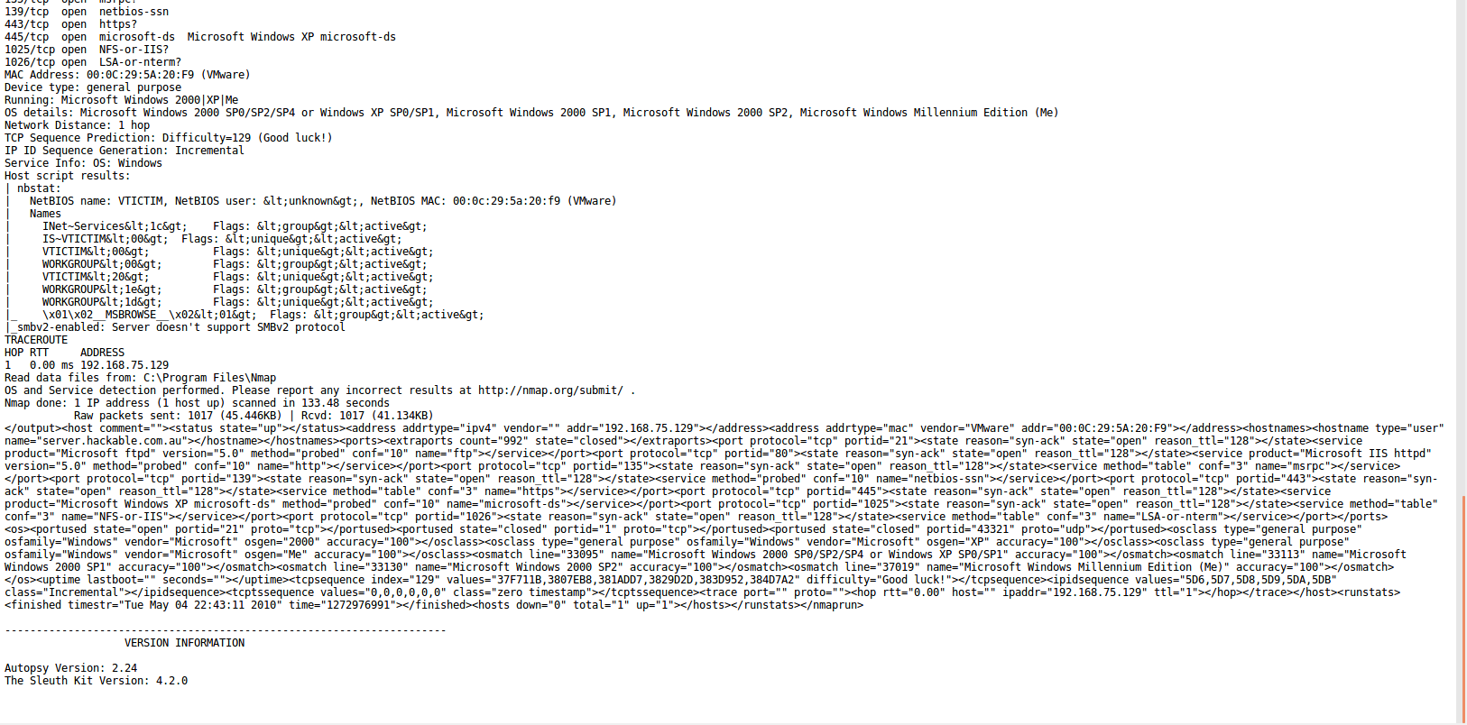

(he attacked at: 22:46:44 2010-05-04 using an NMAP Attack on hackable’s website

At 23:32:16 2010-05-04 he stole users list from the hackable’s website

At 23:35:36 he made(use different wording as he could have downloaded too) the gif file for the logo

At 23:35:36 he also made the webpage that can be seen in exibit 1

(issue is that the md5 and sha1 doesn’t match with that of exibit, so try to find the main webpage on his pc and not just separate parts)

(see everything he did from 22:46:44 to 23:35:36 and see 1 hr before and after the thing in wireshark)

5. Relevant evidence and the explanation of your findings that supports or refutes the hacker’s alibi for the alleged “second” website attack (3 marks)

6. Evidence and explanation for the alleged Facebook account takeover (5 marks)

7. Explanation of the communication method between the hacker and the collaborator including an assessment regarding the use of hidemyass (1 mark)

8. The inclusion of relevant evidence from Timescanner super timeline in your findings (1 mark)

9. Your ability to stick to the facts, and explain your processes and findings in non-technical (but still accurate!) language (2marks) (.5 Reduction for each non-factual statement)

10. Overall presentation of your report (1 mark)